Stage 1 - Python for AI/ML
Stage 2 - Machine Learning - (Train and test)
Stage 3 - How to test the LLM. Design Framework of evaluation. Design agent for evaluation
Stage 4 - RAG and then MCP

Start - 9:30
Break - 11:15 AM IST
End -1:30

https://github.com/balaji-githubstore/python-ai-ml-test-kpmg-feb-2026.git

Stage 1:
AI/ML Testing Concepts

- Traditional QA & AI/ML QA
  - Traditional QA → Does the system work correctly?
  - AI checks → Does the model behave correctly statistically and ethically?
- Traditional QA
  - Deterministic (same input → same output)
  - Logic - rule-based
  - Testing focus - Functional correctness
  - Validation - expected vs actual result
  - Failure type - Bug in code
- AI/ML QA
  - Non-Deterministic (same input → may vary slightly)
  - Logic - Data-Driven
  - Testing focus - Model accuracy, bias, performance
  - Validation - statistical metrics (accuracy, precision, recall)
  - Failure type - Data issue, model drift, bias, overfitting

- Challenges in Non-Deterministic
  - No exact expected output - validate probability
  - Data dependency - Model behaviour changes with new data
  - Model drift - performance might reduce over time
  - Bias & fairness issues - the model may favour one group.
  - Explainability - hard to explain the model and the prediction
  - Reproducibility - the same model might give slightly different output

- Types of AI testing
  - Unit Testing
    - Test individual functions
    - Feature engineering validation
    - Data pre-processing checks
  - Integration Testing
    - Test the data pipeline+model together
    - API response validation
    - Schema validation
  - System testing
    - End-to-end testing
    - Data → Model → API → Output JSON validation
  - Acceptance Testing
    - Business validation
    - Does the model meet the KPI?
    - Is accuracy acceptable?

Python
- Python Installation

- Architecture
- VSCode
  - Add extension → python from Microsoft
  - Set up the virtual environment
    - Ctrl+Shift+P → interpreter → select interpreter → select .venv
- Datatypes
  - Numeric
    - Int
    - Float
  - Sequence datatypes
    - String
    - List
    - Tuple
  - Boolean
  - Dictionary
  - Set
    - Contains unique unordered items
- Conditional statements
  - If condition
- Iterative statements
  - For
  - For each/advance for loop → designed for collections
- String
  - String Substring
- Methods/variable
  - Methods/variable inside the Module
  - Methods/variables inside the class
    - Static methods/variable
    - Non-static non-statics/variable
- Class and Object
  - A class is a template or blueprint from which objects are created.
  - Object
    - An instance of a class
    - Every object has its own state (non-static variable) and behaviour (non-static variable)
Stage 2:
AI/ML libraries
- Pandas
  - DataFrame
    - 2D table (rows*column) (Excel,csv, SQL table)
  - Dataframe allows:
    - Cleaning the missing values
    - Checking duplicates
    - Detecting outliers
    - Feature engineering
    - Statistical summary
    - Model input preparation
- Statistical parameters:
  - Mean →sum of values/number of values
Median (after asc order) → middle number or (middle 2 values)/2

[10,20,30,40,150]
mean> median (50%) → positive skew → check high outlier
mean<median → negative skew → check low outlier
mean=median → balanced → safe

  - Std → Ages typically vary by about +- 18 from the average age 40)
Low std → tightly packed
High std → widely spread

Co-eff of variance (cov): mean/std

Cv →
< 10% → stable
10-30% → moderate
30-50% → high variation
>50% → very high variation (check outliers)

  - IQR (Interquartile range) (take dataset falls under this category → lower to upper bound)

IQR = Q3 (75%) - Q1 (25%)

lower bound = Q1 - 1.5*IQR
Upper bound = Q3 + 1.5*IQR

Case 1: No outlier → all values are between the lower and upper bounds
Case 2: Higher outlier → values > upper bound
Case 2: Lower outlier → values < lower bound

- Validation Report → class

- Machine learning → train the model, predict using the model trained, and evaluate.
- AI, ML, DL, Gen AI
  - AI → Border concept of machine performing tasks → that typically require human intelligence, such as reasoning, learning, decision-making, and problem solving.
  - Machine learning (ML) is a subset of AI where systems learn patterns from data (instead of being explicitly programmed)

ML learns patterns automatically from historical data

  - Deep learning is a subset of ML that uses a neural network with multiple layers.
    - Underlying method to build the model.
    - Best example:
      - Image/text recognition
      - NLP
      - Language model - GPT 4, 5

  - Gen AI → what the model does, not how to build it (Text, images, code, audio)

- Learning Types
  - Supervised learning
  - Unsupervised learning
  - Reinforcement learning
- Supervised learning
  - Learning from the labeled data.
  - Input+correct output is already given
    - When I see X, the answer is Y
  - Regression (predict number)
    - Linear Regression
    - Random Forest Regressor
    - Decision tree regressor
  - Classification (Yes/No)
    - Logistic classifier
    - Random Forest classifier

- Unsupervised learning
  - The dataset has no target/output column.
  - No correct answer given
  - The model finds
    - Patterns
    - Groups
  - Used for
    - Customer segmentation
    - News article grouping → sports, technology
- Reinforcement Learning
  - Learning by trial and error
  - Agent → Takes action → gets rewards/penalty -> learn best strategy

- ML engineer vs AI/ML testing QA
Build & train a model - Tests trained model
Optimize performance - Validation correctness
Tune hyperparameters - Evaluation metrics
Improve accuracy - checks reliability & robustness

- Evals
  - Regression
    - MAE
    - MSE and RMSE
    - R^2 (how much data variance does the model explain?
  - Classification
    - Precision
    - Recall
    - Accuracy (won’t give a clear picture if the data is imbalanced)
    - F1 score
    - Roc-Auc
- Unspervised → Evals
- Machine learning Model: - Flowchart
  - Data Preprocessing
    - Cleaning the missing values
    - Checking duplicates
    - Detecting outliers
    - Statistical summary
    - Model input preparation
    - One hot encoding
  - Feature Selection/Engineering (example, removing id, passenger id)
  - Train/Test split
  - Model selection (Linear Regression, Logistic regression)
  - Model Evaluation
    - Regression
      - MAE
      - MSE and RMSE
      - R^2 (how much data variance does the model explain?
    - Classification
      - Precision
      - Recall
      - Accuracy (won’t give a clear picture if the data is imbalanced)
      - F1 score
      - Roc-Auc
  - Final model and the deployment
  - Prediction on new data

Stage 3:

- LLMs
  - Difference between Traditional ML and LLM

Traditional ML | LLM
Structure output (0/1, number) | National language output
Deterministic | Non-deterministic
Easy to measure | Hard to measure
Fixed evaluation metrics | Human judgment needed

In LLMs, quality is subjective rather than binary.

- Non-deterministic and evaluation challenges
  - The same input to a traditional ML model will always get the same output. It is deterministic (fixed output)
  - Ask the same question to ChatGPT two times
    - We will get a slightly different answer compared to the previous answer
    - Here, non-deterministic in nature

- Why are LLMs non-deterministic?
LLMs predict the next word based on probability.
  - Prompt: I love machine ____
    - Possible next tokens
      - Learning (0.67)
      - Intelligence (0.20)
      - Work (0.13)
    - Depending on:
      - Temperature
      - Sampling strategy
      - Random seed
  - The model may select words based on the settings

- Evaluation challenges in LLMS
  - Traditional ML: yes/no or numbers
  - LLM - multiple valid answers
    - Subjective quality
      - When you prompt something like explain AI, then o/p could be too technical/basic/perfectly balanced.
        - Measure?
          - Clarity
          - Simplicity
          - Usefulness
      - These required human judgment

    - Hallucination problem
      - Prompt: asking who won world cup in 2050
          - The model might generate a name confidently.
          - Testing must detect hallucination
    - Format instability
      - prompt: answer in JSON
      - Testing must validate the same
    - Same input multiple times → verify which is correct? Sometimes both will be correct.

- How does QA need to handle non-deterministic?
  - Avoid checking expected=actual
    - Use Human judgment or rubric scores (manual judgment based on experience)
    - Automate format check, basic prompt output check. (automate using Python libraries)
    - Automated metrics (BLEU & ROUGE, BERTScore)
      - Measure word similarity
      - Measure semantic similarity
      - Reference answer comparison.
  - Use one model to test another model
  - Create dataset (golden)
    - Predefined
      - Prompt
      - Reference response
      - Scoring rubric

- LLM Architecture
  - Overview of LLM
    - User prompt → tokenization → Transformer (Attention) → next token prediction → response generation → safety layer → O/P
  - In-depth
    - Input text → tokenization → embedding layer → positional encoding → Transformer blocks (Repeated N times)--> Output block (cycle continuously until complete responses are generated)

- Where QA validates in the LLM application.
  - Prompt layer testing
    - QA check:
      - Prompt clarity
      - Edge case
      - Role confusion
  - Response layer testing
    - QA check:
      - Relevance
      - Hallucination
      - Format
      - Factual correctness
  - Safety layer testing
    - Test cases:
      - Hate speech
      - Bias
      - Illegal activities
    - Expected
      - Refusal
      - Safe alternative
      - Help resource

  - Tools/Agent Layer testing
    - If LLMs
      - API calls
      - DB queries

    - QA must test:
      - Tools invocation correctness
      - Failure handler
      - Timeout scenario

- Prompt Engineering
  - What makes a good prompt?
    - A good prompt
      - Clear
      - Specific
      - Context-aware
      - Structure
      - Constrained
Example:
Role
Task
Context
Constrained
Role: You are a senior data scientist
Task: Overfitting in machine learning
Context: The audience is junior data scientists with basic knowledge of ML
Constrained: Give it in 3 bullet points. Maximum 120 words
  - Zero Shot vs few shot
    - Zero shot - no example
    - Few shots:
      - Provide example
Text: I have a good mobile
Sentiment: positive
Text: I hate to work
Sentiment: negative
      - Few-shot improves performance
  - Prompt template & Best practices
    - Use delimiters
      - Weak prompt: Summarize the text: the cat sits on the mat
      - Better prompt: Summarize the text
“””

The cat sits on the mat
“””
    - Specific format
      - Weak prompt: explain AI
      - Better prompt: Explain AI
2 bullet points
Simple language
Maximum 50 words

    - Limit length
    - Ask for step-by-step reasoning:
      - Improves accuracy in:
        - math /technical code
        - Logic
        - Multi-step task
      - Weak prompt: What is 2*8?
      - Better prompt: Solve step by step: what is 2*8?

    - Avoid vague instructions
  - System vs User prompt
    - System defines
      - The model’s role
      - The tone
      - The rules
      - The behaviour boundaries
      - It acts like a policy layer

    - User prompt:
      - The actual question
      - The task question/input from the end user

- Sampling parameters
  - Temperature (0 to 2)
    - What does it control? Creativity vs deterministic

0.0 → deterministic, predictable, factual
0.3 - 0.5 → slight variation
0.7 - 1.0 → creative, diverse
>1.0 - very random

  - Top p (0 to 1)
- What does it control? Probability mass selection
- Select from the top probability token until the cumulative prob = p

Sort token by prob ( high→ low)
AI -> 0.5
Machine → 0.4
Car → 0.1

If top_p = 0.5
AI -> 0.5
Machine → 0.4 → stop here

So only two tokens are considered.

1 → no truncation
0.9 → only top 90% cumulative prob
0.5 → very restricted
<0.3 → extreme deterministic

  - Top k (1 to vocabulary size)
What does it control? Limit token choices to the top k most likely tokens
1 -> (same as temperature 0)
40 → common default
100 → more diversity

  - Max token
    - Control - maximum response length

  - Frequency penalty (0 to 2)
    - Reduce the repetition of words
    - Higher value→ discourages repeating the same phrases.

1 → no penalty
0.5 → mild repetition reduction
1 → strong repetition reduction
>1.5 → may distort the sentences
  - Presence penalty
  - Seed
    - Fix randomness
    - Important for evaluation testing

- Ollama
  - Tools that help to run the LLM model locally. (Instead of using cloud AI or through API, we are setting up an open-source local LLM model)
  - Installation
    - Install ollama.exe (https://ollama.com/)
    - Download model (https://ollama.com/search )
      - ollama pull gemma:1b
      - Check Ollama list
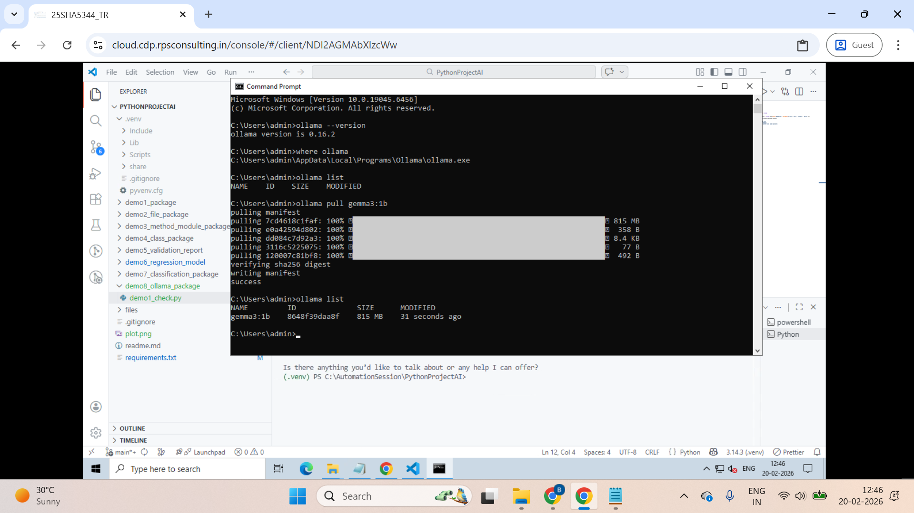
  - Create a sample python code and check it
import ollama
response = ollama.chat(model="gemma3:1b", messages=[{'role': 'user', 'content': 'Hello!'}],)
print(response.message.content)

  - Pros and cons to run in local
    - Pros
      - No api keys required
      - Works offline
      - Full control over the model
    - Cons
      - Required good hardware

- QA works
  - Human judgment evaluation (mostly manual) - can also cover using the deepeval automation framework
  - Automate all the format response length using Python libraries (Prompt response validation)
  - Check for scores like BELU, ROUGE, BERTScore, and SBERTScore using the Hugging Face model for it
  - DeepEval Framework
    - LLM Model
    - RAG+LLM Model
    - Judgment evaluation rubric score

- Automate check on llm output (Using json, pandas)
  - Check package - demo8_ollama_format_test_package

- How to calculate BELU, ROUGE, BERTScore, and SBERTScore, and what to interpret from them for LLM testing?
  - Install libraries (refer to code) - demo1_eval_metrics_test.py
  - Check - demo9_huggingface_eval_package

- DeepEval Framework
  - Check package - demo10_deepevals_package
  - Automation to find all metrics with a custom judge model
demo2_deepeval_llm_metric_test.py
  - LLM -
Architecture
[User input/prompt]→ [LLM] → [Generate output]

    - AnswerRelevancyMetric
    - BiasMetric
    - ToxicityMetric
    - GEval for correctness

  - LLM with RAG (Retrieval Augmented Generation) - demo1_rag_sys_test.py

Architecture
[User input/prompt]→[Retriever] → [LLM] → [Generate output]

[Retriever] → searches the Knowledge base/embeddings → return top relevant document

[LLM]--> receives
Context: <retrieved_doc>
Question: <user_query>

Note: user_query will be sent to the retrieval system instead of LLM directly

    - AnswerRelevancyMetric
    - BiasMetric
    - ToxicityMetric
    - FaithfulnessMetric
    - ContextualRelevancyMetric
    - HallucinationMetric
    - GEval for correctness
  - Automation to get the rubric score with a custom judge model and evaluation steps
demo3_deepeval_rubric_test.py

- Langchain - Langchain is a model wrapper
  - Make it easier to build an application using multiple LLMs and also a system around LLMs
  - LangChain is an open-source orchestration framework used to build complex, LLM-powered applications by connecting large language models (LLMs) to external data, APIs, and memory.

  - With langchain
    - Prompt templates
    - RAG pipelines
    - Memory
    - Tools
    - Agents
- Pytest
  - Create test method
  - Run it
  - Use report 1 (Older one)
    - pip install html-reports
    - In terminal
pytest --html=report.html
  - Dashboard report (downgrade Python )
    - pip install pytest-html-reporter
    - In terminal
pytest --html-report=report1.html

  - Pytest fixture
https://docs.pytest.org/en/stable/explanation/fixtures.html

—-
Basic encoding techniques used in traditional ML
- One hot encoding
- Bag of words

LLM uses:
Method | User By
BPE (Byte Pair Encoding) | GPT models
Sentencepiece | LLaMA
Wordpiece | BERT

—---------------------------------------------------------------------------------------------------------

Git - Git is a free and open source distributed version control system

Architecture
Project (in local machine) → local repo (in local machine specific to project) → remote repo (GitHub, aws code commit)

Assignments

Get the JSON:
- Go to repository - https://github.com/balaji-githubstore/python-ai-ml-test-kpmg-feb-2026.git
- Download files → loan_data.json

Task 1: SECTION 1 – Basic Inspection

- Load the JSON file (loan_data.json) into a Pandas DataFrame.
- Display:
  - First 5 rows
  - Data types
  - Total number of records
- Count:
  - Total missing values
  - Missing values per column

SECTION 2 – Data Cleaning and Visualization
- Load the JSON file (loan_data.json) into a Pandas DataFrame.
- Check the statistical summary
- Perform the following on the DataFrame :
- Remove duplicates
- Handle missing salary
- Remove invalid ages (Below 18 and above 100 are invalid)
- Fix the negative salary
- Remove empty city rows
- Check the statistical summary
- Plot line between age and salary

—--------------------

- Import
  - You can import package
  - You can import class
  - You can import method
  - You can import variable

Reference
- AI, ML, DL, Gen AI
- Machine learning (traditional ML in a QA perspective)

Reference:

